**FINANCE SQL QUERIES**

1. **KPIs**
2. Total Loan Applications

SELECT COUNT(DISTINCT id) AS Total_Loan_Applications

FROM financial_loan;



1. MTD Loan Applications

SELECT COUNT(DISTINCT id) AS Total_Loan_Applications

FROM financial_loan

WHERE MONTH(issue_date) = 12 AND YEAR(issue_date) = 2021;



1. PMTD Loan Applications

SELECT COUNT(DISTINCT id) AS Total_Loan_Applications

FROM financial_loan

WHERE MONTH(issue_date) = 11 AND YEAR(issue_date) = 2021;



1. Total Funded Amount

SELECT SUM(loan_amount) AS Total_Funded_Amount

FROM financial_loan;



1. MTD Funded Amount

SELECT SUM(loan_amount) AS MTD_Funded_Amount

FROM financial_loan

WHERE MONTH(issue_date) = 12 AND YEAR(issue_date) = 2021;



1. PMTD Funded Amount

SELECT SUM(loan_amount) AS PMTD_Funded_Amount

FROM financial_loan

WHERE MONTH(issue_date) = 11 AND YEAR(issue_date) = 2021;



1. Total Amount Recieved

SELECT SUM(total_payment) AS Total_Amount_Recieved

FROM financial_loan;



1. MTD Amount Recieved

SELECT SUM(total_payment) AS MTD_Amount_Recieved

FROM financial_loan

WHERE MONTH(issue_date) = 12 AND YEAR(issue_date) = 2021;

1. PMTD Amount Recieved

SELECT SUM(total_payment) AS PMTD_Amount_Recieved

FROM financial_loan

WHERE MONTH(issue_date) = 11 AND YEAR(issue_date) = 2021; 

1. Average Interest Rate

SELECT ROUND(AVG(int_rate), 4)*100 AS Average_Interest_Rate

FROM financial_loan;



1. MTD Average Interest Rate

SELECT ROUND(AVG(int_rate), 4)*100 AS MTD_Average_Interest_Rate

FROM financial_loan

WHERE MONTH(issue_date) = 12 AND YEAR(issue_date) = 2021; 

1. PMTD Average Interest Rate

SELECT ROUND(AVG(int_rate), 4)*100 AS PMTD_Average_Interest_Rate

FROM financial_loan

WHERE MONTH(issue_date) = 11 AND YEAR(issue_date) = 2021;



1. Average DTI Ratio

SELECT ROUND(AVG(dti),4)*100 AS Average_DTI_Ratio

FROM financial_loan;



1. MTD Average DTI Ratio

SELECT ROUND(AVG(dti),4)*100 AS MTD_Average_DTI_Ratio

FROM financial_loan

WHERE MONTH(issue_date) = 12 AND YEAR(issue_date) = 2021;



1. PMTD Average DTI Ratio

SELECT ROUND(AVG(dti),4)*100 AS PMTD_Average_DTI_Ratio

FROM financial_loan

WHERE MONTH(issue_date) = 11 AND YEAR(issue_date) = 2021;



1. **Good Loans Issued**
2. Good Loan Percentage

SELECT ROUND((COUNT(CASE WHEN loan_status = 'Fully Paid' OR loan_status = 'Current' THEN id END) * 100.0) / COUNT(id), 2)

AS Good_Loan_Percentage

FROM financial_loan;



1. Good Loan Applications

SELECT COUNT(id) AS Good_Loan_Applications

FROM financial_loan

WHERE loan_status = 'Fully Paid' OR loan_status = 'Current';

1. Good Loan Funded Amount

SELECT SUM(loan_amount) AS Good_Loan_Funded_Amount

FROM financial_loan

WHERE loan_status = 'Fully Paid' OR loan_status = 'Current';



1. Good Loan Total Received Amount

SELECT SUM(total_payment) AS Good_Loan_Total_Received_Amount

FROM financial_loan

WHERE loan_status = 'Fully Paid' OR loan_status = 'Current';



1. **Bad Loans Issued**
2. Bad Loan Percentage

SELECT ROUND((COUNT(CASE WHEN loan_status = 'Charged Off' THEN id END) * 100.0) / COUNT(id), 2)

AS Bad_Loan_Percentage

FROM financial_loan;



1. Bad Loan Applications

SELECT COUNT(id) AS Bad_Loan_Applications

FROM financial_loan

WHERE loan_status = 'Charged Off';



1. Bad Loan Funded Amount

SELECT SUM(loan_amount) AS Bad_Loan_Funded_Amount

FROM financial_loan

WHERE loan_status = 'Charged Off';



1. Bad Loan Total Received Amount

SELECT SUM(total_payment) AS Bad_Loan_Total_Received_Amount

FROM financial_loan

WHERE loan_status = 'Charged Off';



1. **Loan Status**

SELECT

loan_status,

COUNT(id) AS LoanCount,

SUM(total_payment) AS Total_Amount_Received,

SUM(loan_amount) AS Total_Funded_Amount,

ROUND(AVG(int_rate * 100), 2) AS Interest_Rate,

ROUND(AVG(dti * 100), 2) AS DTI_Ratio

FROM financial_loan

GROUP BY loan_status;

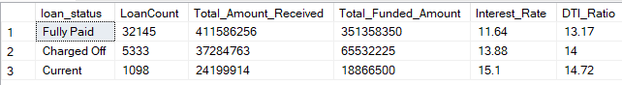

1. **MTD Loan Status**

SELECT

loan_status,

SUM(total_payment) AS MTD_Total_Amount_Received,

SUM(loan_amount) AS MTD_Total_Funded_Amount

FROM financial_loan

WHERE MONTH(issue_date) = 12

GROUP BY loan_status;

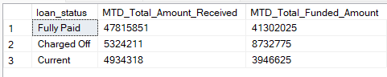

1. **PMTD Loan Status**

SELECT

loan_status,

SUM(total_payment) AS PMTD_Total_Amount_Received,

SUM(loan_amount) AS PMTD_Total_Funded_Amount

FROM financial_loan

WHERE MONTH(issue_date) = 11

GROUP BY loan_status;

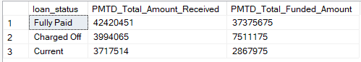

1. **Bank Loan Report**
2. Month

SELECT

MONTH(issue_date) AS Month_Munber,

DATENAME(MONTH, issue_date) AS Month_name,

COUNT(id) AS Total_Loan_Applications,

SUM(loan_amount) AS Total_Funded_Amount,

SUM(total_payment) AS Total_Amount_Received

FROM financial_loan

GROUP BY MONTH(issue_date), DATENAME(MONTH, issue_date)

ORDER BY MONTH(issue_date);

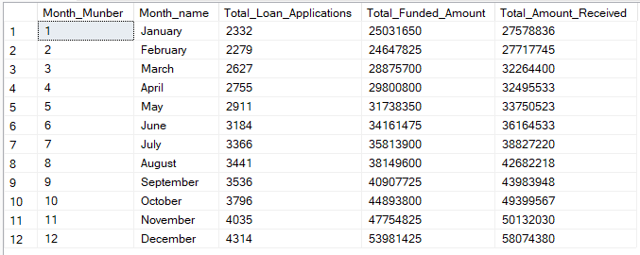

1. State

SELECT

address_state AS State,

COUNT(id) AS Total_Loan_Applications,

SUM(loan_amount) AS Total_Funded_Amount,

SUM(total_payment) AS Total_Amount_Received

FROM financial_loan

GROUP BY address_state

ORDER BY address_state;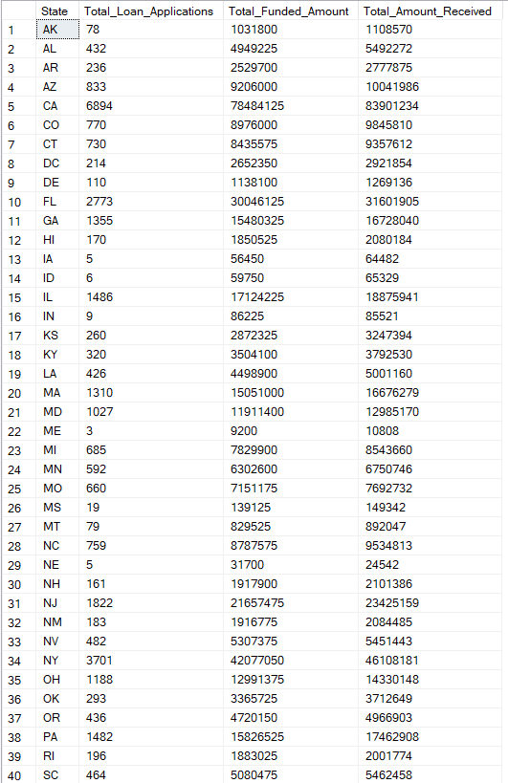

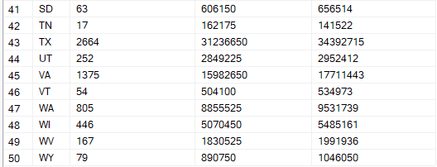

1. Term

SELECT

term AS Term,

COUNT(id) AS Total_Loan_Applications,

SUM(loan_amount) AS Total_Funded_Amount,

SUM(total_payment) AS Total_Amount_Received

FROM financial_loan

GROUP BY term

ORDER BY term;

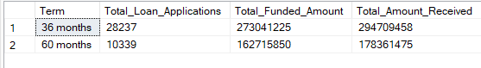

1. Employee Duration

SELECT

emp_length AS Employee_Duration,

COUNT(id) AS Total_Loan_Applications,

SUM(loan_amount) AS Total_Funded_Amount,

SUM(total_payment) AS Total_Amount_Received

FROM financial_loan

GROUP BY emp_length

ORDER BY emp_length;

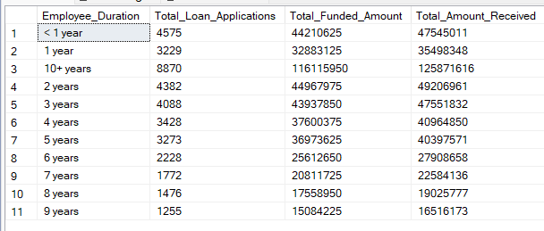

1. Purpose

SELECT

purpose AS Purpose,

COUNT(id) AS Total_Loan_Applications,

SUM(loan_amount) AS Total_Funded_Amount,

SUM(total_payment) AS Total_Amount_Received

FROM financial_loan

GROUP BY purpose

ORDER BY purpose;

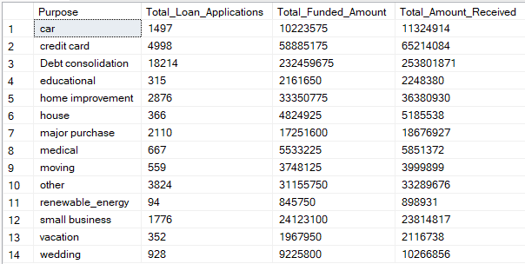

1. Home Ownership

SELECT

home_ownership AS Home_Ownership,

COUNT(id) AS Total_Loan_Applications,

SUM(loan_amount) AS Total_Funded_Amount,

SUM(total_payment) AS Total_Amount_Received

FROM financial_loan

GROUP BY Home_Ownership

ORDER BY Home_Ownership;

